**03.AWS-B30-IPAddressing-VPCIntro**

--- **note** – in this session, we will discuss about subnetting and aws vpc.

**Subnetting**

--- IPV4 is 32-bit address.

--- **important** - 10.0.0.0 here each digit place is 8-bit so, we have total 4-digit place that is why we call IPV4 is a 32-bit.

--- **important** - 10.0.0.0 or 10.0.0.0/8 – aws does not support 10.0.0.0/8, It will only support 10.0.0.0/16.

--- **important** - the cider block must be between /16 to /28.

**Best practice to create subnet**

--- **Reference** - https://www.subnet-calculator.com/

--- **scenario** – we have a requirement to create subnets for webservers, app servers and db servers.

The number of subnets required are below

1. Webservers – 10
2. App servers – 20
3. Db servers - 30

**VPC**

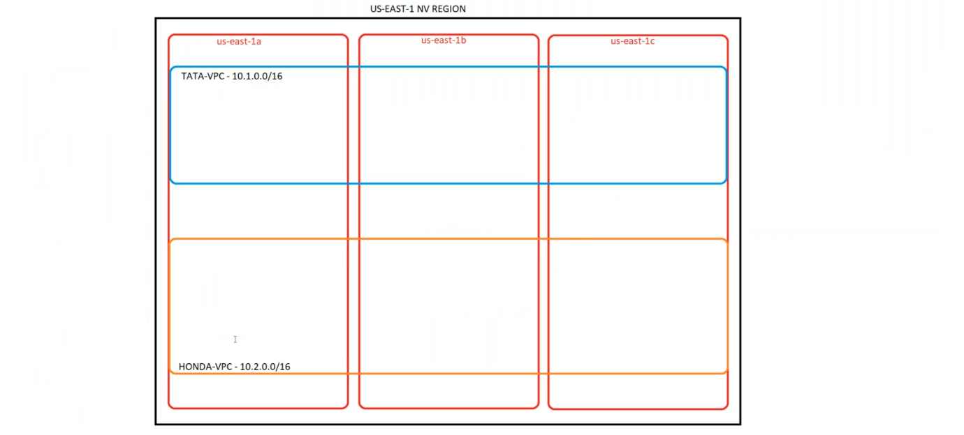

--- VPC is region base.

--- by default, there is no communication between 2 VPC’s

--- **note** – here we have us-east-1a, us-east-1b and us-east-1c zones. The VPC is span across the all availability zones within the region.

**Create VPC**

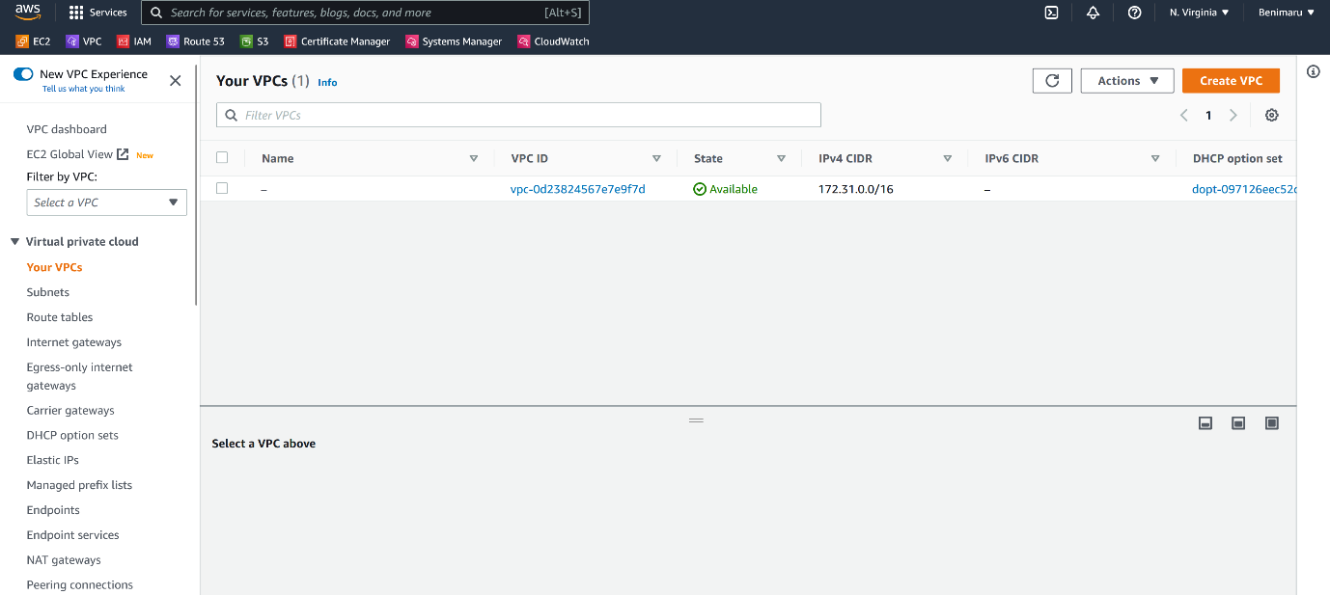

--- Click on create VPC.

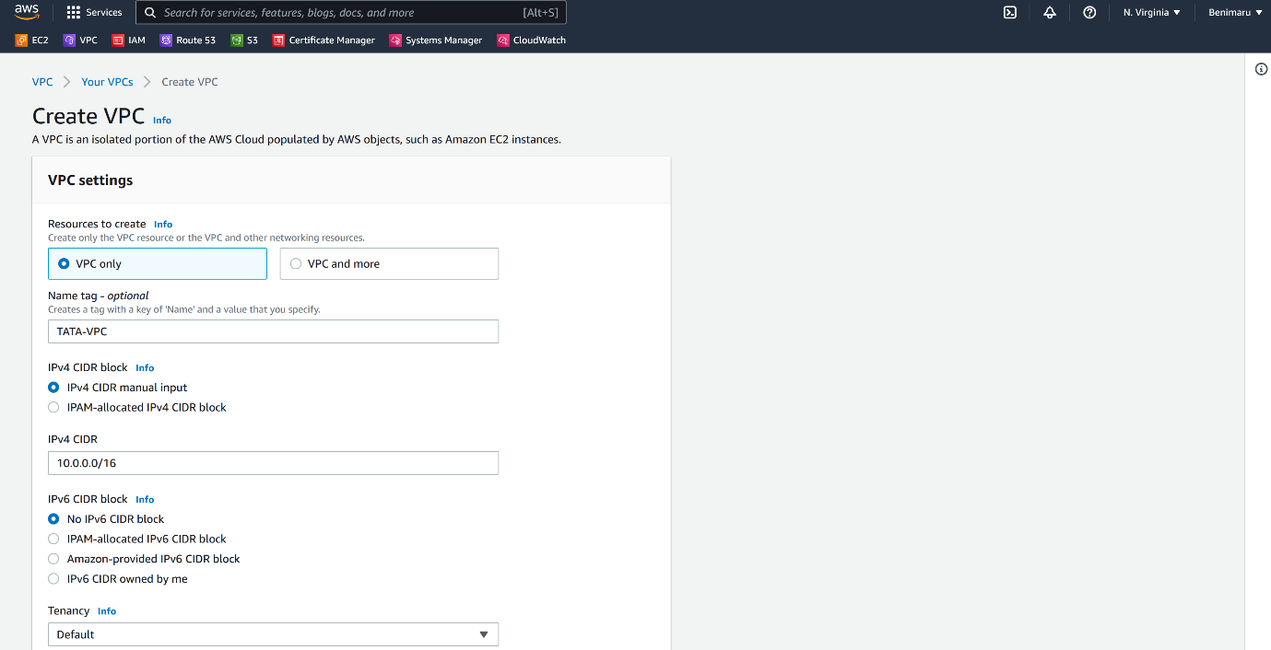

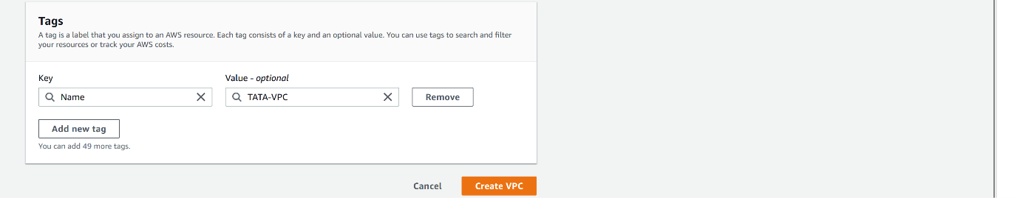

--- Click on create VPC.

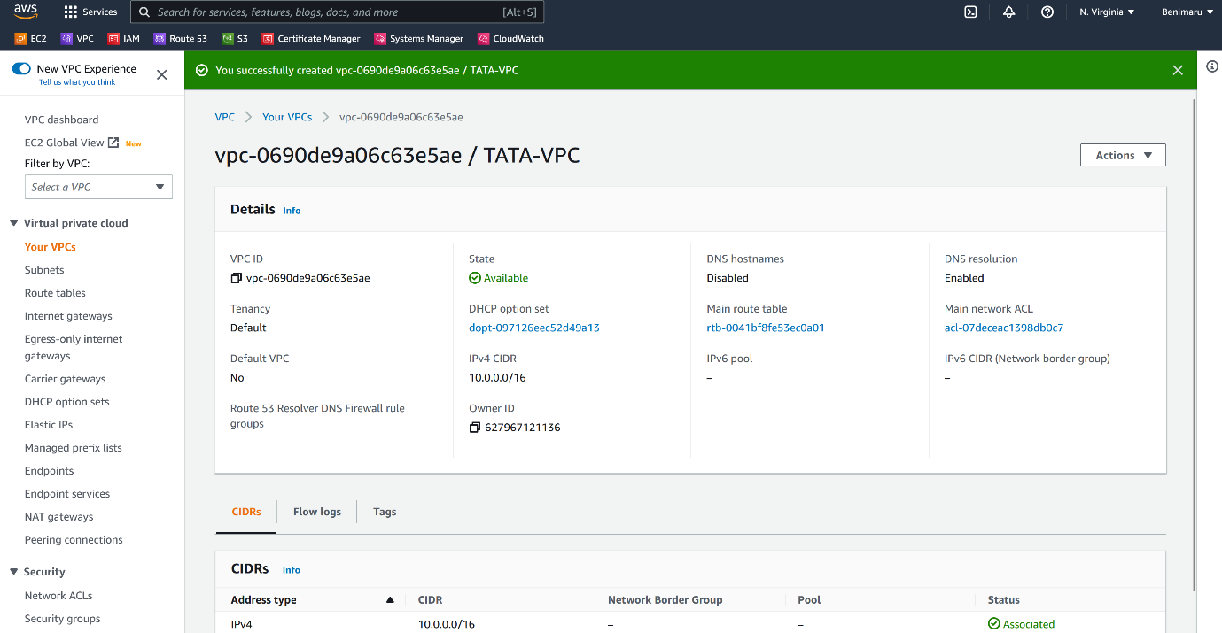

--- **note** – our vpc is created successfully.

--- **important** – if you want to use the VPC then we need to create subnets from the VPC.

**Subnet creating**

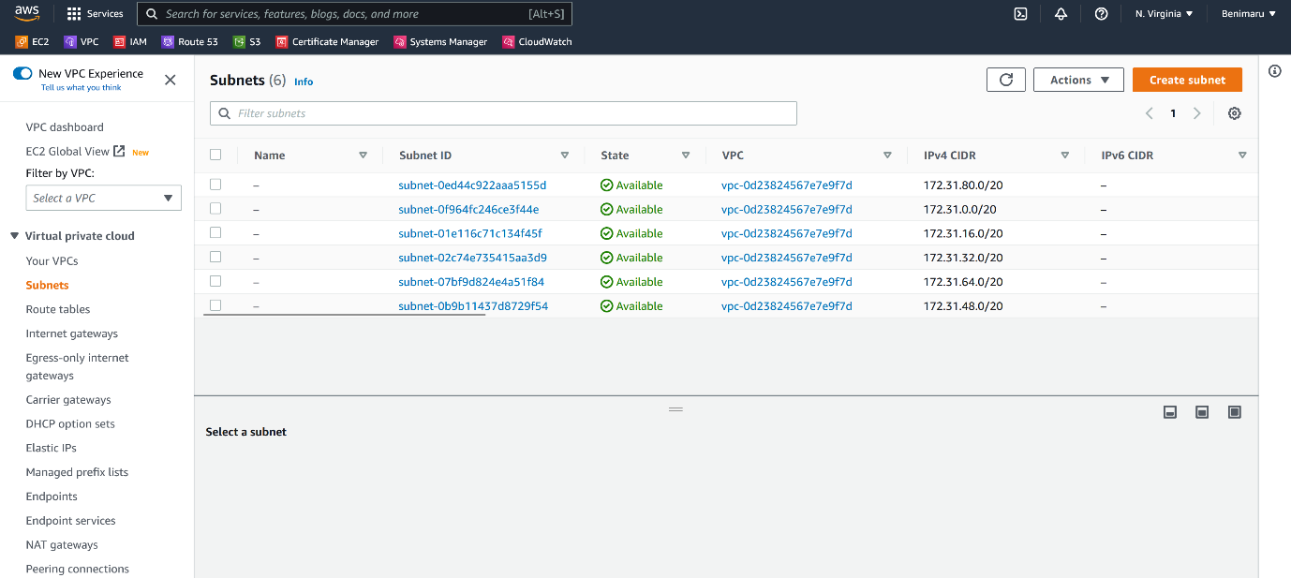

--- Click on create subnet.

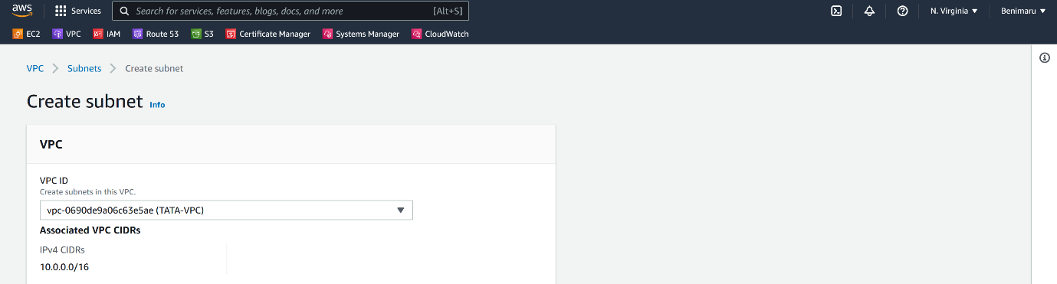

--- Select the VPC.

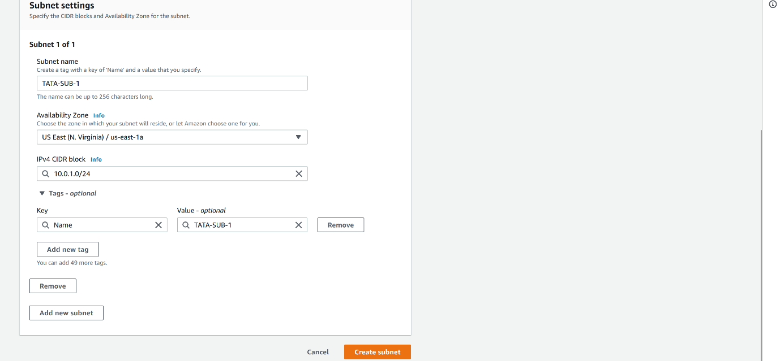

--- click on create subnet.

**Communication of server in same VPC**

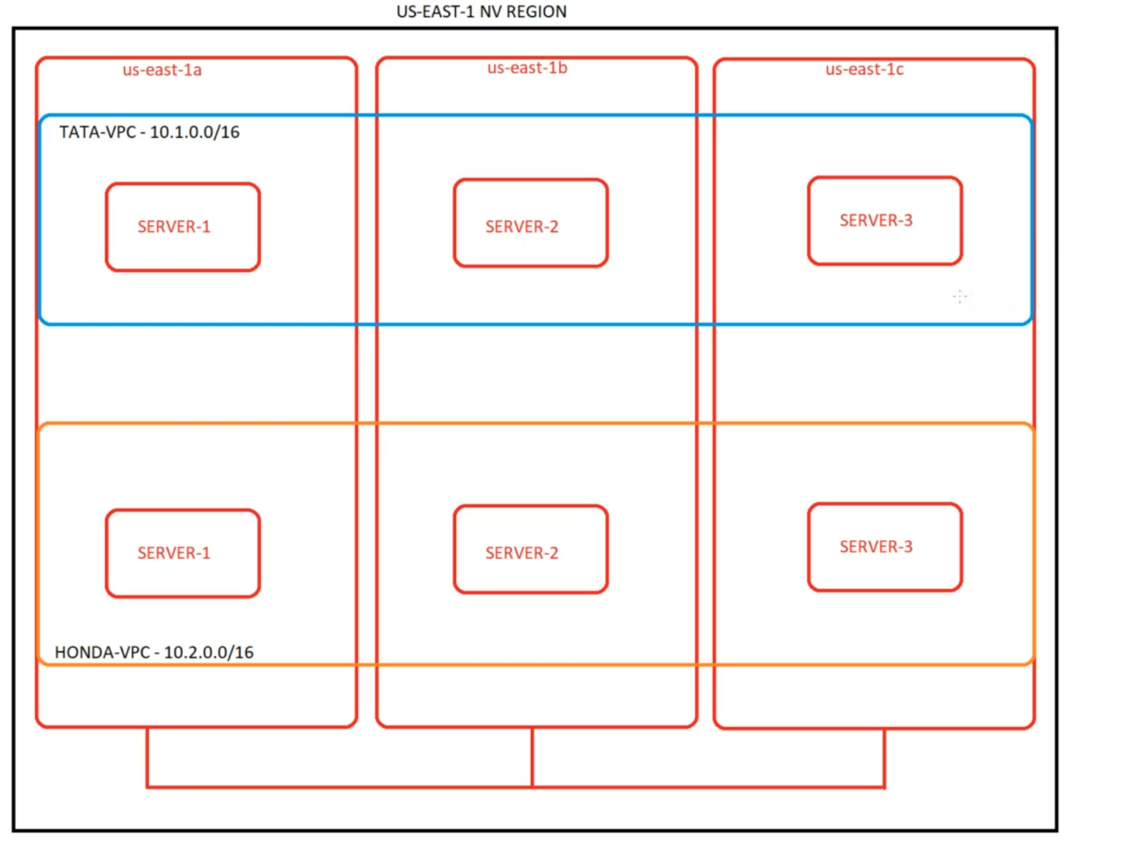

--- **NOTE** – we have deployed our servers in us-east-1a, us-east-1b and us-east-1c. these 3 servers are deployed in same vpc. By default, the communication between these is enabled. These servers can talk to each other.

**Internet gateway**

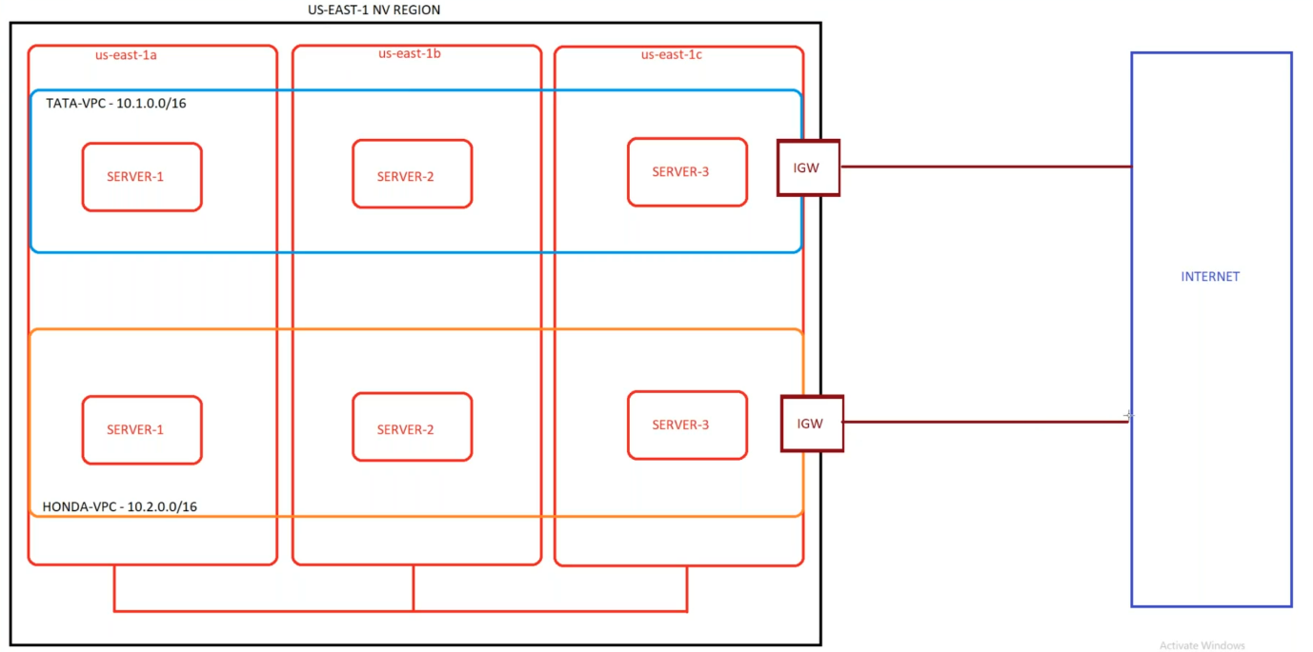

--- **note** – if you want to enable the internet connection to the server which is present inside of the vpc then we need to create internet gateway and attach that internet gateway to the vpc.

**Create internet gateway**

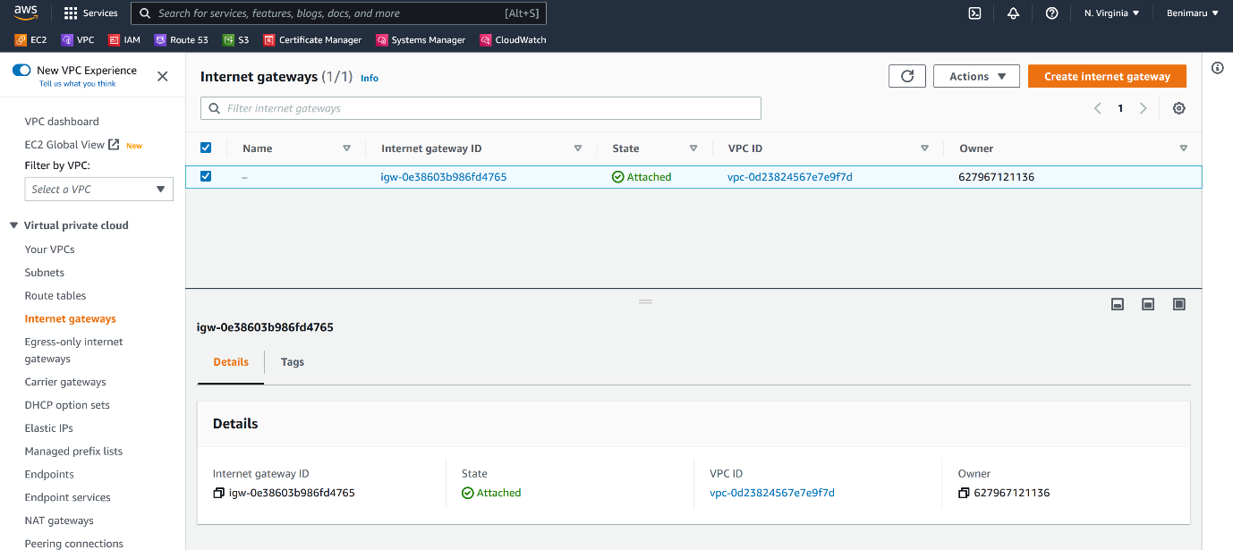

--- Click on create internet gateway.

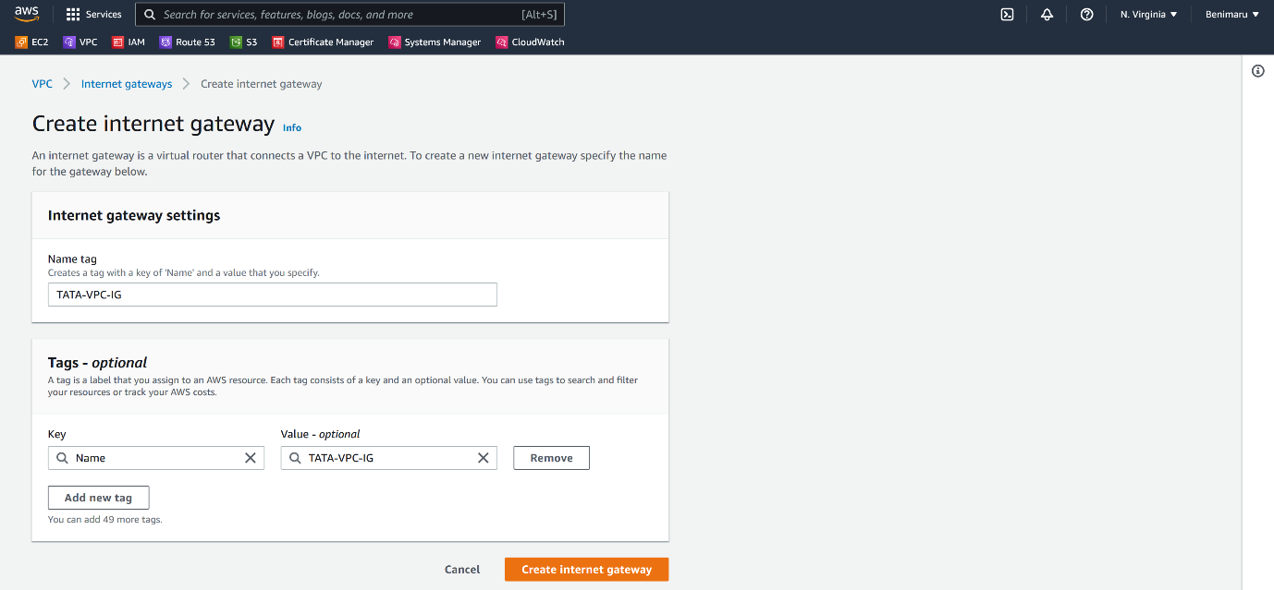

--- click on create internet gateway.

**Attach the internet gateway to vpc**

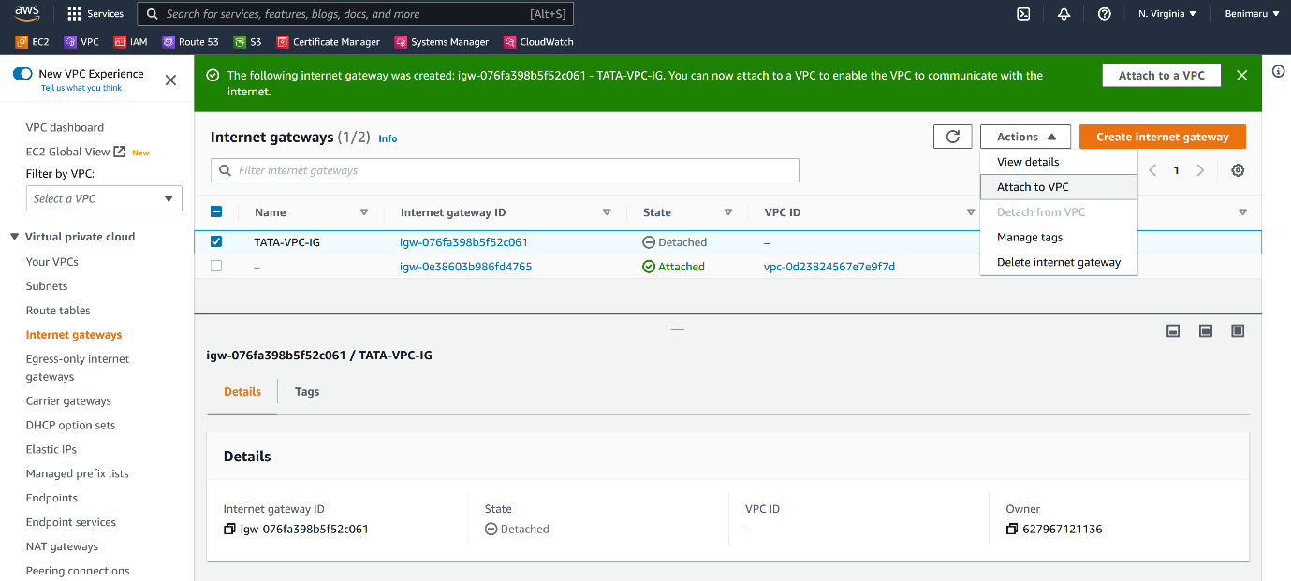

--- **note** – click on attach to vpc.

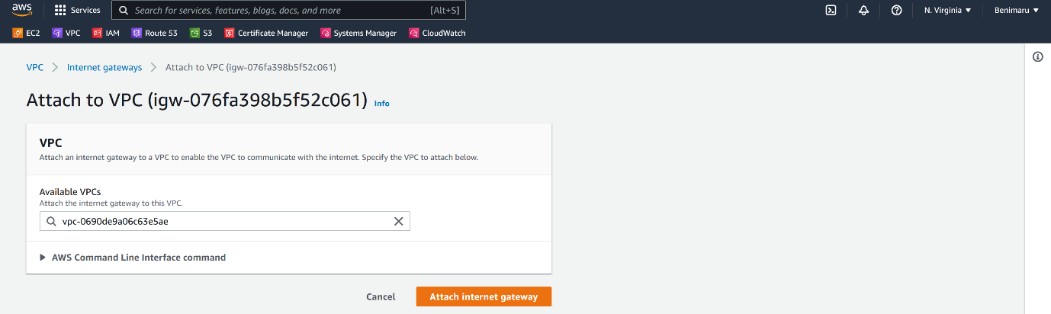

--- **note** – please select the vpc that you want to attach it to and click on attach internet gateway.

**Route tables.**

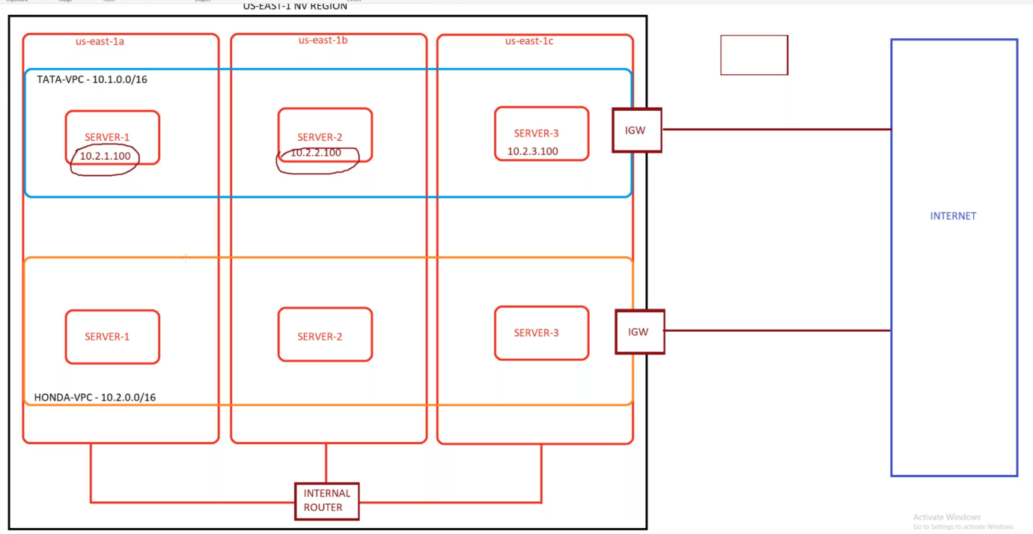

--- **note** – route table will route the traffic to outside and it will guide the traffic.

**Create route table**

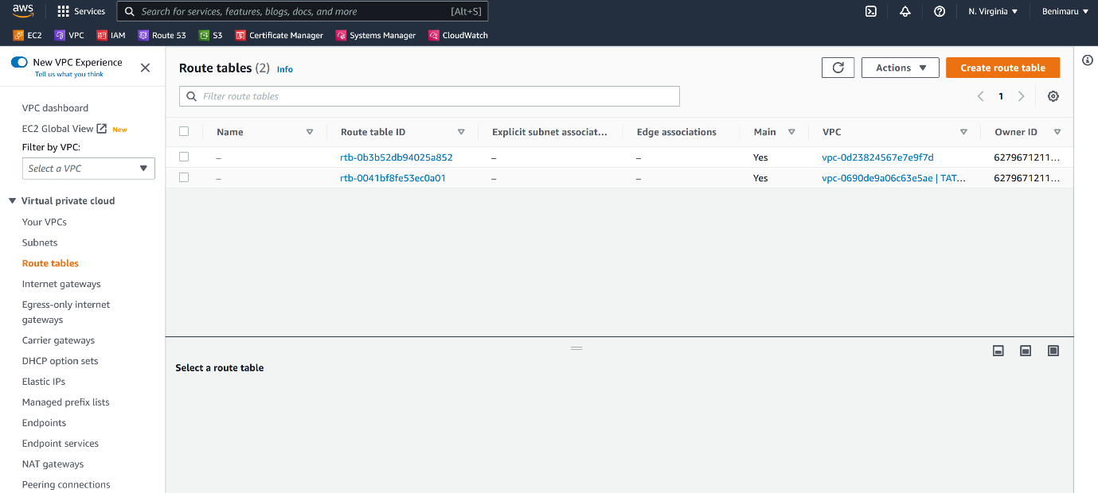

--- click on create route table.

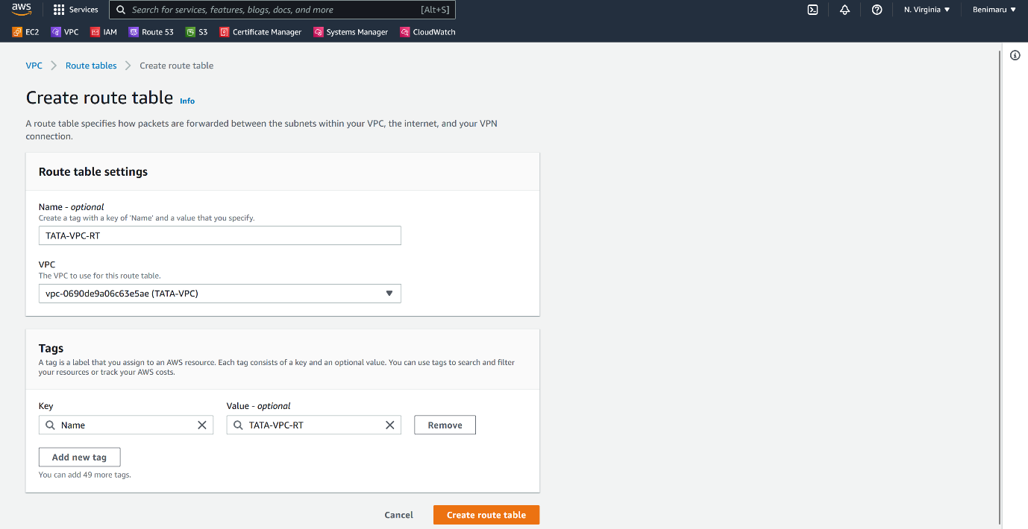

--- click on create route table

**Subnet association**

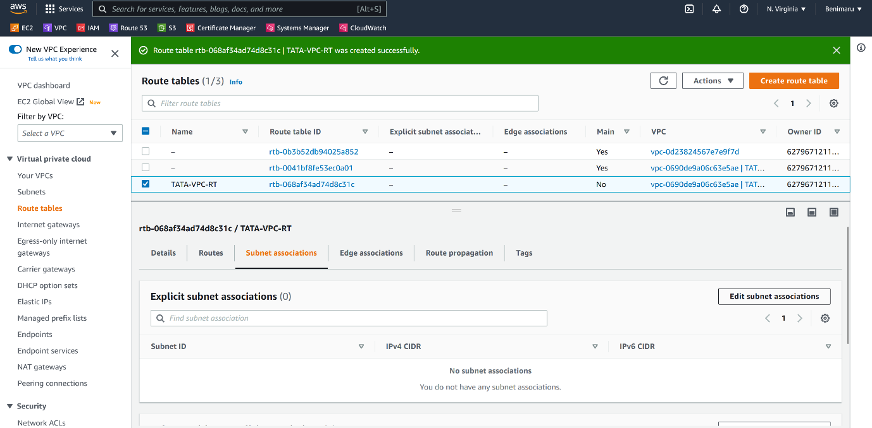

--- **note** – click on edit subnet associations.

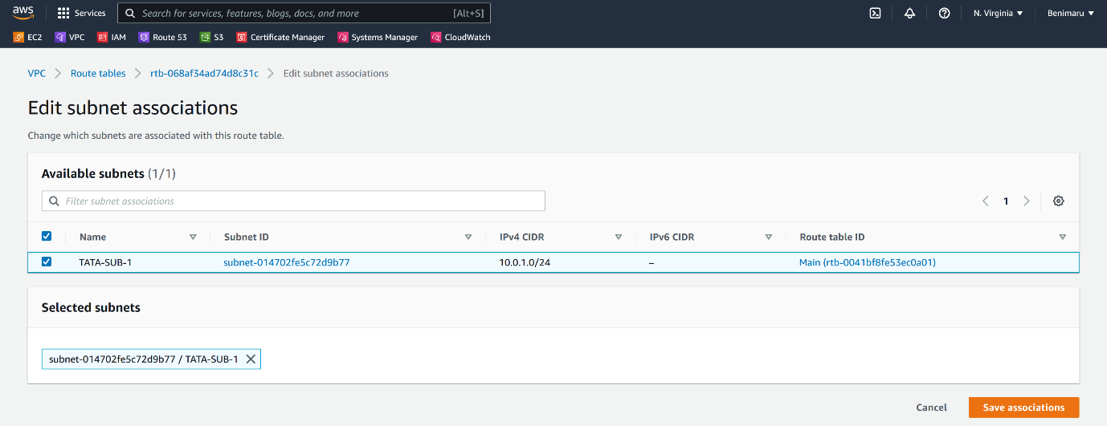

--- select the subnets and save associations.

**Routes**

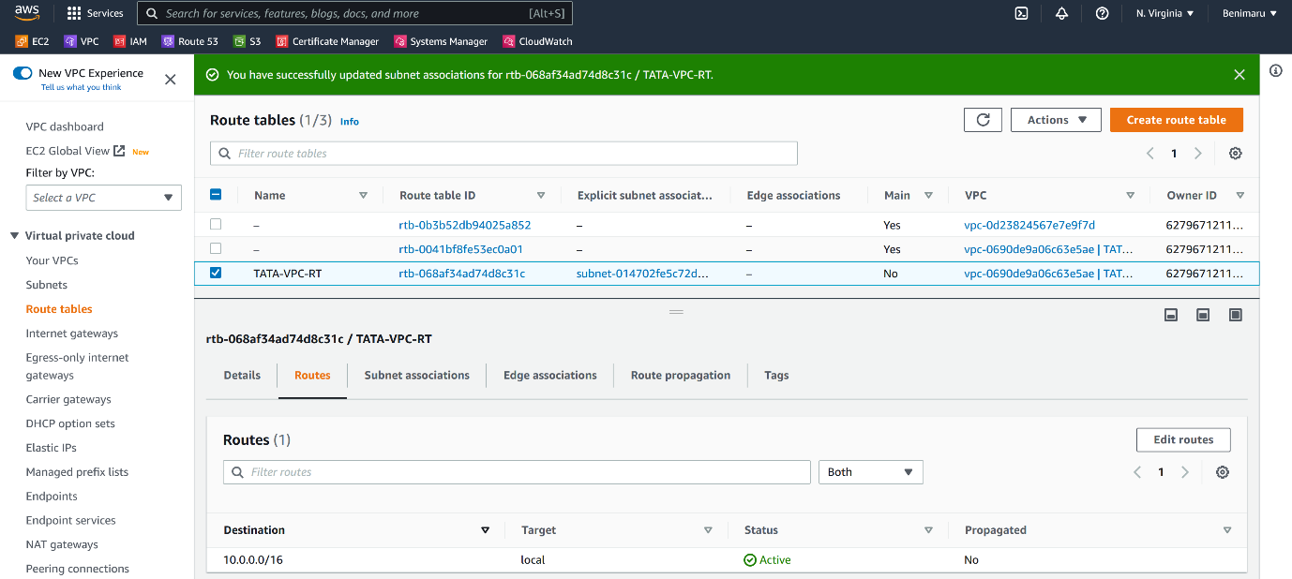

--- click on edit routes.

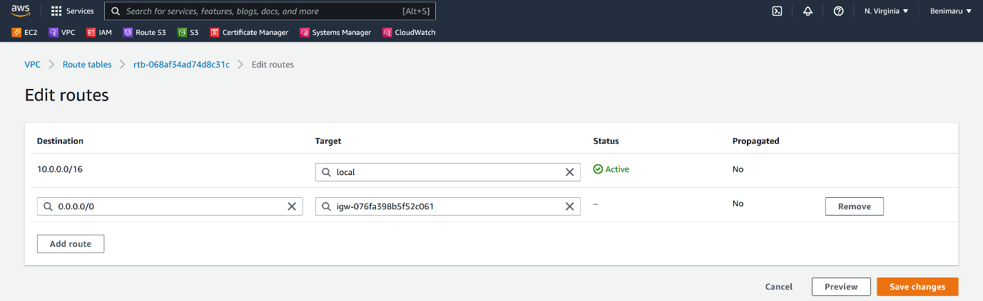

--- click on save changes.

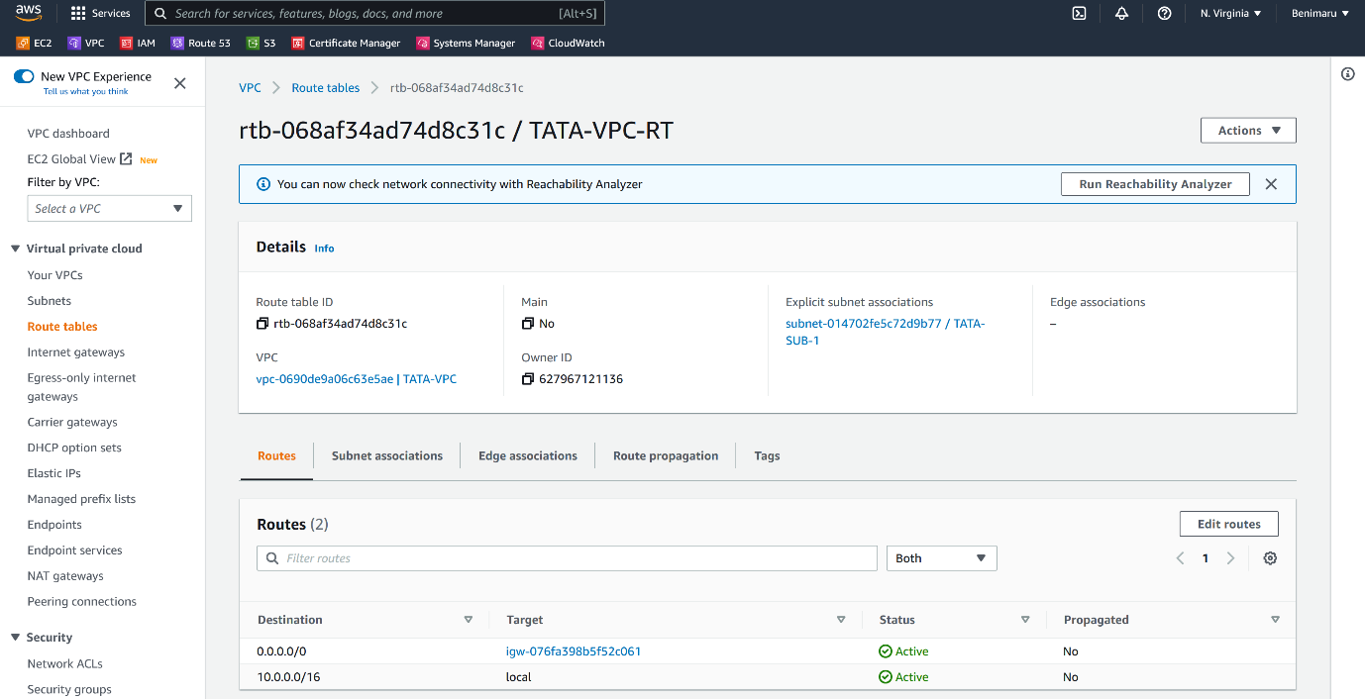

--- **note** – if the destination is 10.0.0.0/16 then establish a communication internally.

--- **note** – if the destination 0.0.0.0/16 then use the internet gateway route.

**Security group creating**

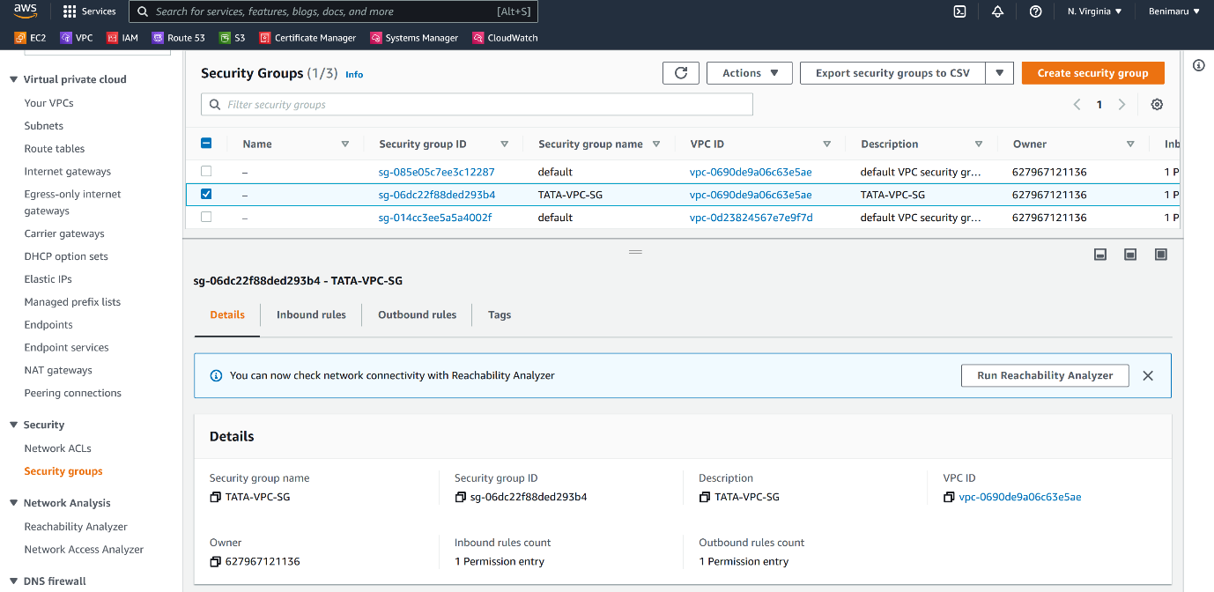

--- click on create security group.

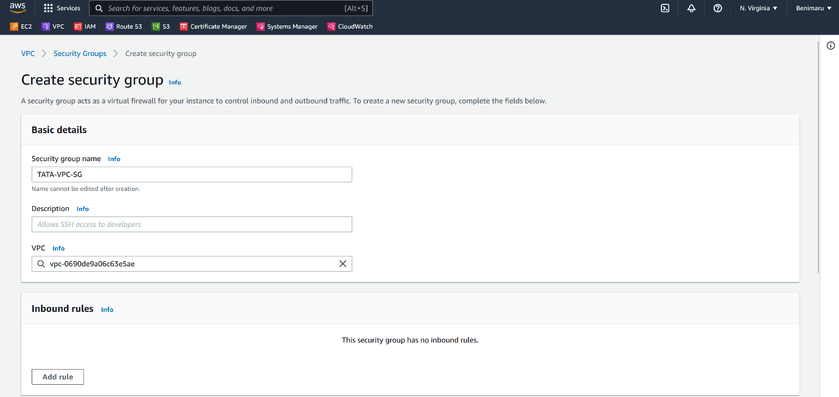

--- note – select the vpc that you want to attach this security group and please give the Description.

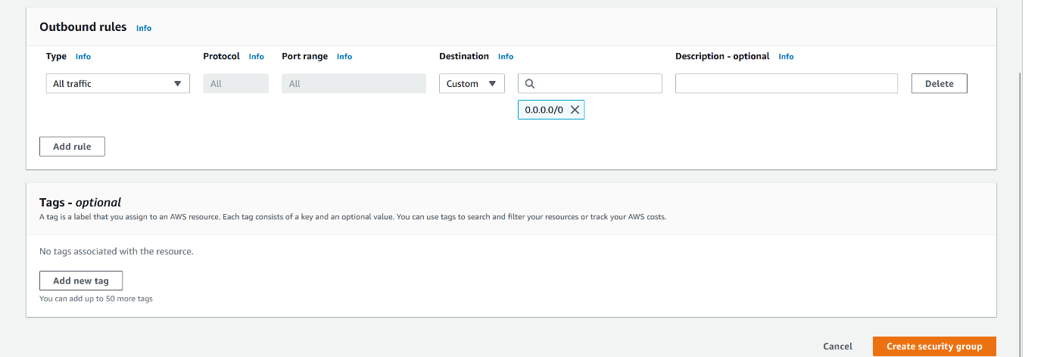

--- click on create security group.

